Spring AI
What is AI (Artificial Intelligence)?
Artificial Intelligence (AI) means making computers think, learn, and act like humans.
It’s all about writing software that can:
- Understand data
- Learn from it
- Make decisions or predictions
Example:
- Google Maps predicting traffic
- Netflix recommending movies
- ChatGPT generating answers
- Chatbots handling customer support

🧠 1. Model
A Model (specifically a Large Language Model or LLM) is the core AI system, such as GPT-4, Gemini, Llama 2, etc. It's a machine learning model that has been trained on massive amounts of data to understand, generate, and process human language.
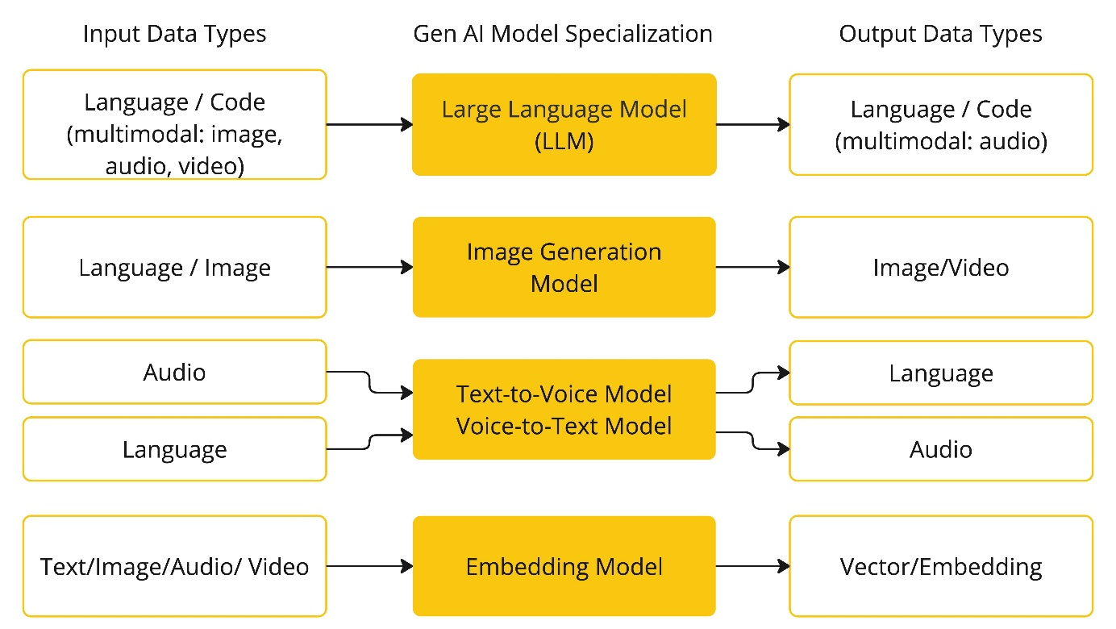
In Spring AI, you interact with these models through classes like:
@Autowired
private ChatClient chatClient;
➡️ The model processes your prompt and returns the text.

💬 2. Prompt
A Prompt is the input you provide to the LLM to get a response. It's the instruction, question, or text that guides the model's generation.
In Spring AI: This is often a simple String or a more complex object (Prompt) that you pass to the ChatClient's call method.
- Example: "Write a short poem about a sunny day."

🧩 3. Prompt Template
A Prompt Template is a pre-defined structure or blueprint for a prompt that allows you to dynamically insert values. It helps ensure consistent, high-quality, and repeatable instructions for the LLM.
- In Spring AI: You use the PromptTemplate class to define the structure and placeholders ( { } ). You then fill these placeholders using a Map of input variables before creating the final Prompt object.
  - Example Template: "You are a helpful assistant. Answer the user's question about {topic}. The question is: {question}"
PromptTemplate template = new PromptTemplate("Explain {topic} in simple terms");
Prompt prompt = template.create(Map.of("topic", "Polymorphism"));
String answer = chatClient.call(prompt).getResult().getOutput().getContent();

🔢 4. Embedding
An Embedding is a numerical representation (a vector or list of numbers) of a piece of text (a word, sentence, or document).
Why?
Because computers can’t “understand” words — they understand numbers.
So embeddings turn words or sentences into numerical arrays that capture meaning.
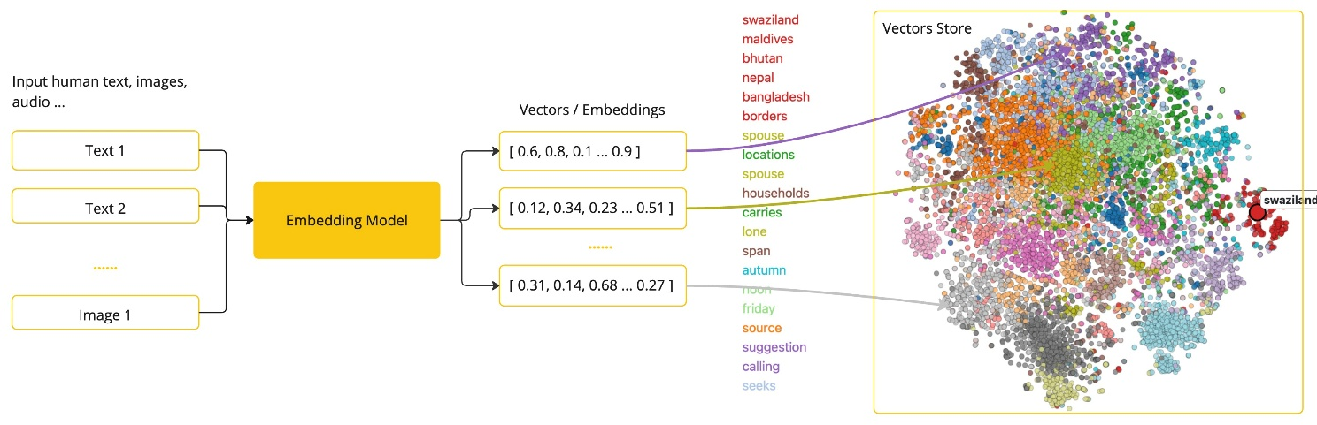
- In Spring AI: You use the EmbeddingClient to convert text data into vectors, which are crucial for the Retrieval Augmented Generation (RAG) process.

🪙 5. Token
A token is the smallest unit of text an LLM processes.
Think of tokens as word pieces, not full words.
The cost of using a model and the length of its input and output are measured in tokens.
On input, models convert words to tokens. On output, they convert tokens back to words.
In Spring AI: The framework helps manage token usage and calculates the total tokens used in a request and response.
- Example: The word "Spring" might be one token, while "ReinforcementLearning" might be three.
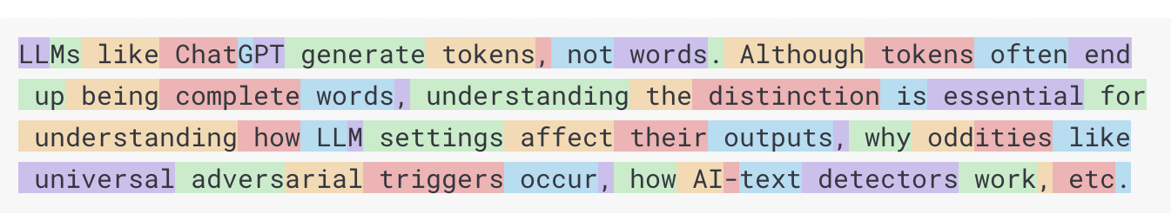
⚙️ Why it matters:
- Cost: API pricing is usually per token.
- Length limit: Models have max tokens (e.g., GPT-4 = 128k tokens).
- Performance: Larger prompts = slower response.

📊 6. Structured Output
Structured Output is the process of forcing the LLM to generate its response in a predictable, defined format, typically JSON. This is critical when you need the model's output to be consumed directly by another piece of code or service.
Normally, LLMs return plain text.
But what if you want structured JSON, like a Java object?
In Spring AI: This is often achieved by providing the LLM with a JSON Schema or a Java Class (e.g., a record or POJO) using an annotation (like @FunctionCallingConfiguration) or a specific method chain, so the model knows the exact structure it must adhere to.
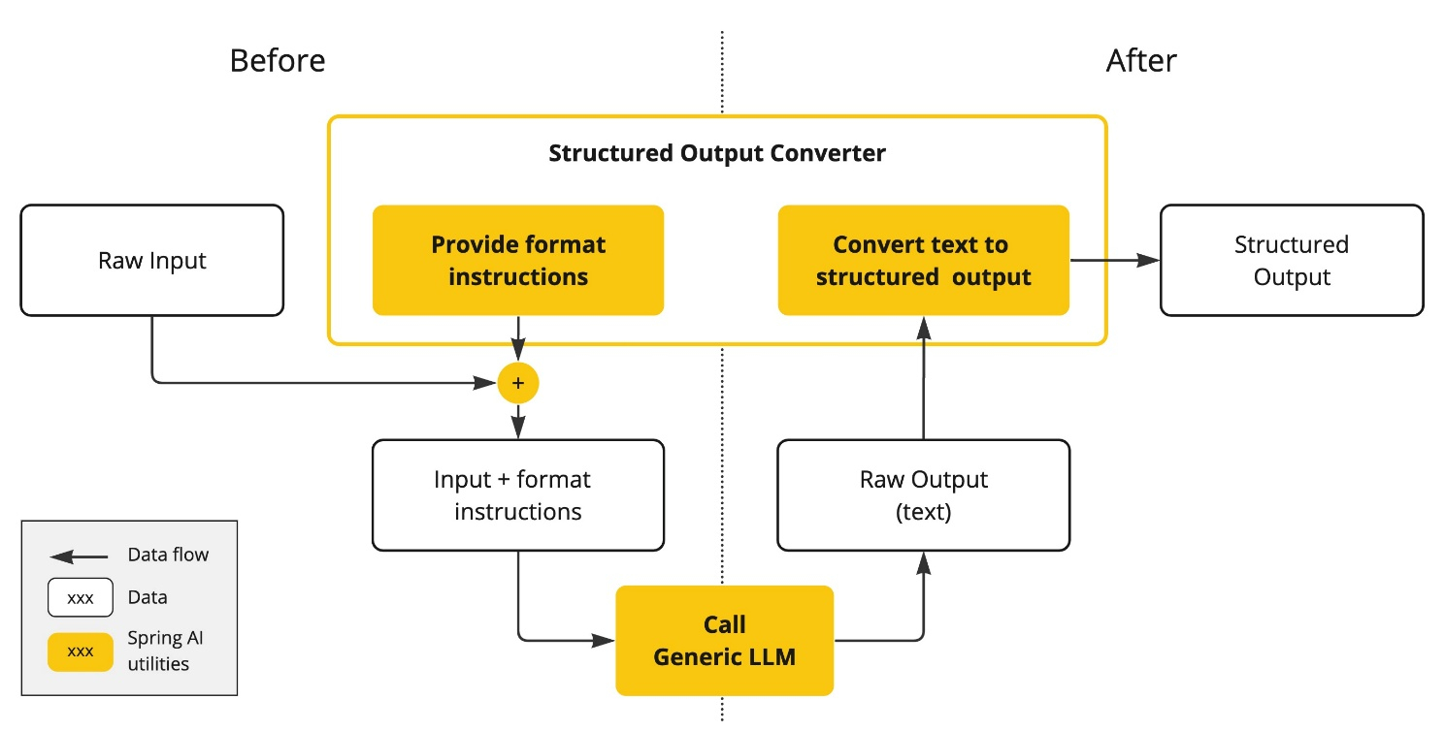

In Spring AI, you can define a class:
record Movie(String title, String genre, String director) {}
Then ask the model to return:
Movie movie = chatClient.call(prompt, Movie.class);

✅ You get a strongly-typed Java object instead of raw text!

📚 7. Retrieval-Augmented Generation (RAG)
It means:
Before the AI model (like ChatGPT or OpenAI GPT) gives an answer, it first retrieves real, relevant information from your own data — then uses that data to generate a better, factual response.

Why Do We Need RAG?
LLMs (Large Language Models) like GPT are trained on massive data but only up to a certain time (cutoff) and they don’t know your private/company data.
Example:
If you ask: “What is the refund policy of my company?”
The model doesn’t know, because it was never trained on your company’s internal documents.
So, we use RAG to feed your data into the model at query time, so it can answer using updated, accurate information.
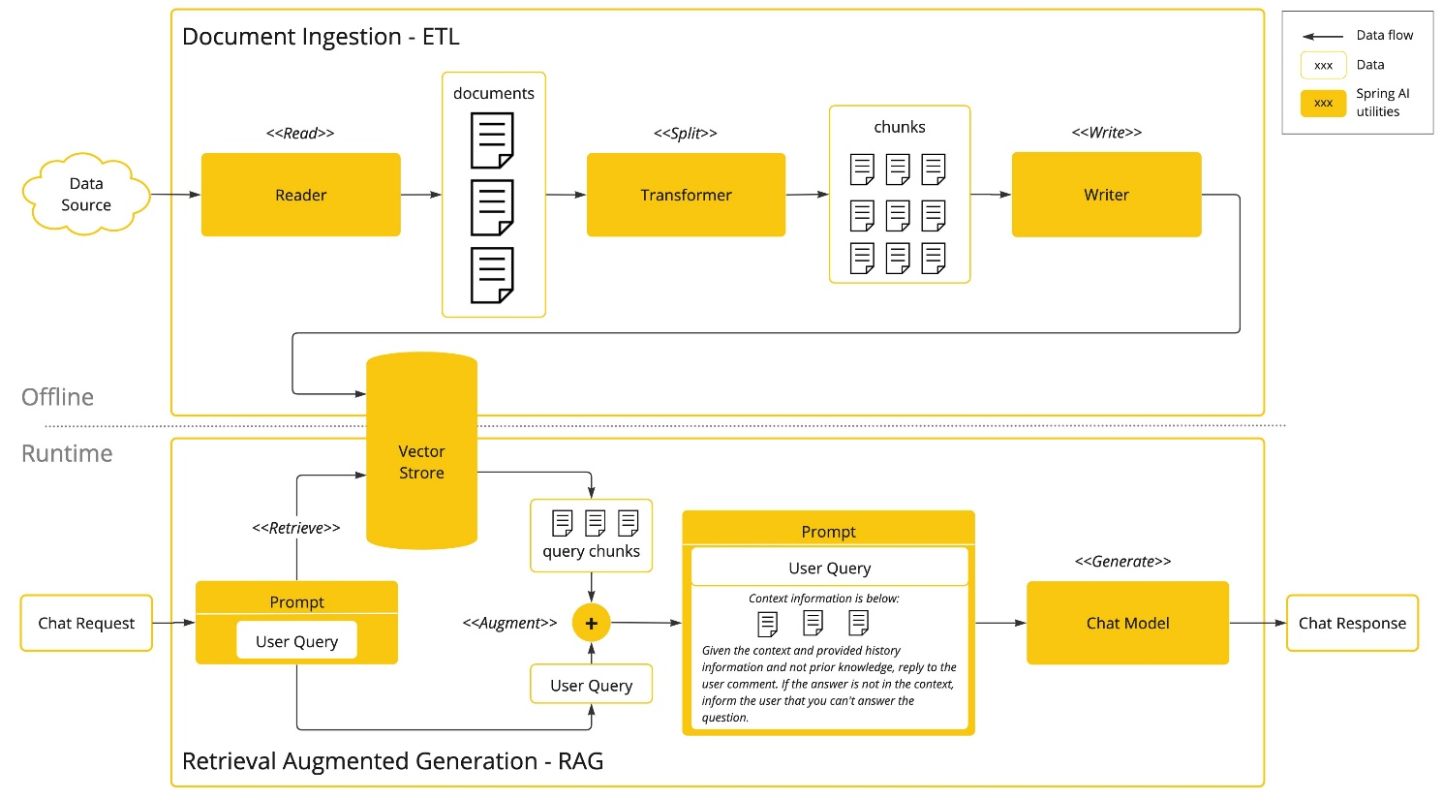
The RAG flow is:
- Index/Store: Convert your documents into Embeddings and store them in a Vector Database.
- Retrieve: When a user asks a question, convert the question into an Embedding, use it to search the Vector Database for the most semantically relevant chunks of your original data.
- Augment & Generate: Insert the retrieved data chunks into the Prompt Template and send the augmented prompt to the LLM for final answer generation.

🧰 8. Tool Calling (a.k.a. Function Calling or AI Agents)
Tool Calling means the AI can invoke external tools, APIs, or functions dynamically when needed.
Think of it as giving AI superpowers to take actions beyond text generation.
In Spring AI: You register Java methods as "tools" with the framework. When a user asks something like, "What is the weather in London?", the model recognizes it needs a get_current_weather(city: str) function, tells Spring AI to call it, and then uses the function's result to generate a final, informed natural language response.

ChatModel
ChatModel is an interface that represents the core abstraction for interacting with AI language models. It's the lower-level component that handles the actual communication with AI providers.
Key Characteristics:
ChatModel is a functional interface with a single method: call(Prompt prompt) which returns a ChatResponse. This method takes a structured Prompt object containing messages and optional settings, then communicates with the underlying AI provider (OpenAI, Anthropic, Ollama, etc.) and returns the model's response.
ChatModel acts as a direct bridge to the AI provider's API. It handles request formatting, API calls, and response parsing. Different implementations exist for different providers—OpenAiChatModel, AnthropicChatModel, OllamaChatModel, etc.
The response you get back is a ChatResponse object containing the generated message, token usage information, and metadata about the completion. ChatModel is relatively low-level, so you work directly with Message and Prompt objects.
How to Use ChatModel:
- Define a Prompt: A Prompt object contains one or more Message objects (e.g., SystemMessage, UserMessage).
- Call the Model: Pass the Prompt to the call method.
- Process the Response: The method returns a ChatResponse, from which you can extract the AI's output.

import org.springframework.ai.chat.model.ChatModel;
import org.springframework.ai.chat.prompt.Prompt;
import org.springframework.ai.chat.prompt.SystemMessage;
import org.springframework.ai.chat.prompt.UserMessage;
import org.springframework.ai.chat.messages.Message;
import org.springframework.ai.chat.model.ChatResponse;
import org.springframework.beans.factory.annotation.Autowired;
import org.springframework.stereotype.Component;
import java.util.List;
@Component
public class MyAiService {
private final ChatModel chatModel;
// Spring will auto-inject the configured ChatModel (e.g., OpenAiChatModel)
@Autowired
public MyAiService(ChatModel chatModel) {
this.chatModel = chatModel;
}
public String generateJoke(String topic) {
// 1. Create a Prompt
SystemMessage systemMessage = new SystemMessage("You are a helpful assistant that tells funny jokes.");
UserMessage userMessage = new UserMessage("Tell me a joke about " + topic);
Prompt prompt = new Prompt(List.of(systemMessage, userMessage));
// 2. Call the Model
ChatResponse response = chatModel.call(prompt);
// 3. Process the Response
return response.getResult().getOutput().getContent();
}
}

ChatClient
What is ChatClient?
The ChatClient interface is a higher-level, simplified API built on top of ChatModel in Spring AI used to communicate with chat-based AI models (like GPT-4, Claude, Gemini, etc.).
It acts as a unified interface, similar to Spring's RestTemplate, WebClient, or RestClient, allowing you to communicate with various AI models (like OpenAI, Google Gemini, Azure, Ollama, etc.) without coupling your application code to a specific vendor's SDK.
The ChatClient is designed with a fluent API, allowing you to chain methods to build complex requests easily.
The fundamental interaction pattern is:
ChatClient → prompt() or builder() → parameters/options → call() → response

Key Characteristics:
- Convenience & Fluency: It provides a fluent API that is much more concise.
- Flexible Output: It can return a String directly or a ChatResponse if you need more details.
- Asynchronous Support: It easily supports both synchronous (call) and asynchronous (stream) calls.
- Hides Complexity: It often abstracts away the creation of the full Prompt object.

Primary Methods:
- ChatClient.call(String message): Synchronous call that returns a String.
- ChatClient.prompt().call().content(): The fluent builder pattern for synchronous calls.
- ChatClient.prompt().stream().content(): The fluent builder pattern for streaming (asynchronous) responses.

import org.springframework.ai.chat.client.ChatClient;
import org.springframework.stereotype.Component;
import java.util.Map;
@Component
public class MySimpleAiService {
private final ChatClient chatClient;
// Spring will auto-inject a pre-configured ChatClient
public MySimpleAiService(ChatClient chatClient) {
this.chatClient = chatClient;
}
public String generateJoke(String topic) {
// Using the fluent API in its most concise form
return chatClient.prompt()
.system("You are a helpful assistant that tells funny jokes.")
.user("Tell me a joke about {topic}")
.param("topic", topic) // For variable substitution
.call() // Synchronous call
.content(); // Directly get the String content
}
// Example of streaming (asynchronous)
public Flux<String> generateJokeStream(String topic) {
return chatClient.prompt()
.user("Tell me a joke about " + topic)
.stream() // Asynchronous call returning a Flux
.content();
}
}

The Relationship
It's crucial to understand that ChatClient uses ChatModel under the hood.
When you call chatClient.prompt()...call(), the ChatClient:
- Takes your user and system messages from the fluent API.
- Builds a Prompt object.
- Delegates the call to the underlying ChatModel.call(prompt) method.
- Processes the ChatResponse and returns the simple String content (or the full response if you ask for it).

⚙️ Methods of ChatClient
ChatClient uses a fluent builder pattern that allows you to chain method calls to construct your request. The main entry point is the prompt() method, which returns a PromptSpec to start building
Here's the complete flow of the fluent API:
ChatClient -> .prompt() -> PromptSpec -> .user()/.system() -> UserSpec -> .call()/.stream() -> Response

Let’s go through all the important methods one by one 👇
1. Starting Point: prompt()
This is always your starting point. It returns a PromptSpec that lets you define the prompt content.
PromptSpec prompt = chatClient.prompt();

2. PromptSpec Methods
After calling prompt(), you get a PromptSpec with these main methods:
.system(String message)
- Purpose: Adds a system message that sets the AI's behavior, context, or role.
- Returns: PromptSpec (for chaining)
- Can be called multiple times: Yes, messages are appended
chatClient.prompt()
.system("You are a helpful assistant that speaks like a pirate.")
.system("Always give short answers.")
// ... more configuration

.system(Message message)
- Purpose: Same as above but accepts a pre-created Message object.
- Useful for: Reusing message templates or complex message types.
SystemMessage systemMsg = new SystemMessage("You are a pirate");
chatClient.prompt()
.system(systemMsg)
// ...

.user(String message)
- Purpose: Adds a user message - the main input/question from the user.
- Returns: UserSpec (moves to the next stage of building)
- Can be called multiple times: No, this transitions to UserSpec

chatClient.prompt()
.system("You are a chef")
.user("How do I make scrambled eggs?")
// Now you're working with UserSpec

.user(Message message)
- Purpose: Same as above but with a pre-created Message object.
.messages(Message... messages) / .messages(List<Message> messages)
- Purpose: Add multiple messages at once, in order.
- Useful for: Building complex conversation histories.

List<Message> conversation = Arrays.asList(
new SystemMessage("You are a math tutor"),
new UserMessage("What is 2+2?"),
new AssistantMessage("2+2 equals 4"),
new UserMessage("Now explain why")
);
chatClient.prompt()
.messages(conversation)
// ...

3. UserSpec Methods
After calling .user(), you get a UserSpec with these methods:
.param(String key, Object value)
- Purpose: Provides parameters for template variable substitution.
- Can be called multiple times: Yes
chatClient.prompt()
.system("You are a {role}")
.user("Write a {type} about {topic}")
.param("role", "poet")
.param("type", "poem")
.param("topic", "spring")
.call()
.content();

.params(Map<String, Object> params)
- Purpose: Provide all parameters at once as a map.
Map<String, Object> params = Map.of(
"role", "historian",
"era", "Roman Empire"
);
chatClient.prompt()
.system("You are a {role}")
.user("Tell me about the {era}")
.params(params)
.call()
.content();

.advisors(ChatModelAdvisor... advisors)
- Purpose: Add advisors that can modify the prompt before sending.
- Advisors can: Add context, modify messages, implement retrieval-augmented generation (RAG)
chatClient.prompt()
.user("What's the weather like?")
.advisors(weatherAdvisor, contextAdvisor)
.call()
.content();

.options(ChatOptions options)
- Purpose: Set model-specific parameters like temperature, top-p, etc.
- Returns: UserSpec (for chaining)
// For OpenAI
OpenAiChatOptions options = OpenAiChatOptions.builder()
.temperature(0.7)
.maxTokens(500)
.build();
chatClient.prompt()
.user("Write a creative story")
.options(options)
.call()
.content();

.call() - SYNCHRONOUS
- Purpose: Execute the chat request synchronously (blocking).
- Returns: Response (final response object)

Response response = chatClient.prompt()
.user("Hello world")
.call(); // Blocks until complete response is received

.stream() - ASYNCHRONOUS
- Purpose: Execute the chat request asynchronously (non-blocking).
- Returns: Flux<Response> (stream of response chunks)

Flux<Response> stream = chatClient.prompt()
.user("Tell me a long story")
.stream(); // Returns immediately with a Flux

4. Response Methods
After calling .call() or subscribing to the .stream() Flux, you work with Response objects:

.getResult()
- Purpose: Get the ChatResponse containing full metadata.
- Contains: Output, usage statistics, finish reason, etc.

ChatResponse chatResponse = chatClient.prompt()
.user("Hello")
.call()
.getResult();
// Access metadata
Usage usage = chatResponse.getUsage();
String finishReason = chatResponse.getResult().getMetadata().getFinishReason();

.getMetadata()
- Purpose: Direct access to response metadata.
.getOutput()
- Purpose: Get the assistant's response as a Message object.
.getContents()
- Purpose: Get a list of all content pieces (usually just one).
.content() - MOST COMMON
- Purpose: Get the assistant's response as a simple String.
- Most frequently used: For simple text extraction.
String answer = chatClient.prompt()
.user("What is AI?")
.call()
.content(); // Returns just the text response

What are Options?

Options in Spring AI are the configuration settings you pass to a model call to control how the model behaves (which model to use, how creative it should be, token limits, penalties, tool-calling behavior, etc.).
Technically there’s a base ModelOptions → ChatOptions (chat-specific) and provider-specific implementations (e.g. OpenAiChatOptions).’

Where you set options (three levels)
- Global defaults (startup) — set in application.yml/properties under spring.ai.<provider>.chat.options.*. These become the default options for all calls.
- ChatClient default options — when you build a ChatClient you can supply default ChatOptions programmatically.
- Per-call / runtime overrides — pass options on a single request (via the Prompt / fluent API). Per-call options override defaults for that request. This is the common pattern for tuning per use-case.

Common / Important Fields (what they mean)
These are defined on ChatOptions (portable) and exposed or extended by provider classes (e.g. OpenAiChatOptions).
- model — which model name to use (e.g. gpt-4o, gpt-3.5-turbo, claude-3).
- temperature (Double) — controls randomness/creativity (0.0 = deterministic, 1.0 = creative). Use low for factual tasks, higher for creative tasks.
- maxTokens / maxCompletionTokens (Integer) — upper bound on generated tokens. Note: OpenAI distinguishes some “reasoning” vs “non-reasoning” models and has mutually exclusive limit params — be careful which param to use per model.
- top_p / top_k — nucleus/top-k sampling controls alternative token selection strategies (model dependent).
- frequency_penalty / presence_penalty — discourage repetition or encourage new topics.
- stop sequences — strings that, if generated, cause the model to stop (useful to bound output).
- logitBias — nudge probability of specific tokens (advanced).
- n (number of completions) — request multiple alternative outputs.
- streaming flag — enable streaming responses (token-by-token) instead of waiting for full completion.
- responseFormat / structured output — ask the model to return a JSON/typed schema that Spring AI can parse into a POJO.
- tool-calling / function calling flags — enable or tune the model’s ability to call registered functions (tool calling), including flags like proxyToolCalls or parallelToolCalls in OpenAI options.

OpenAiChatOptions options = OpenAiChatOptions.builder()
.temperature(0.7)
.maxTokens(1000)
.topP(0.95)
.frequencyPenalty(0.5)
.presencePenalty(0.3)
.model("gpt-4") // Specific to OpenAI
.logitBias(Map.of("token_id", 100)) // OpenAI-specific
.stop(Arrays.asList("END", "STOP")) // Stop sequences
.build();
How to configure — examples

A. Application-level defaults (application.yml)
spring:
ai:
openai:
api-key: ${OPENAI_API_KEY}
chat:
options:
model: gpt-4o
temperature: 0.2
max-tokens: 800

These values become the defaults for the OpenAI chat client at startup.

B. Programmatic default when building ChatClient

ChatOptions defaults = ChatOptions.builder()
.model("gpt-4o")
.temperature(0.2F)
.maxTokens(800)
.build();
ChatClient client = ChatClient.builder()
.defaultOptions(defaults)
.build();

you can set default options on the client so most calls don’t need to pass them.

C. Global Default Options
@Configuration
public class AiConfig {
@Bean
public OpenAiChatOptions defaultOpenAiOptions() {
return OpenAiChatOptions.builder()
.temperature(0.7)
.maxTokens(1000)
.model("gpt-4")
.build();
}
}
You can also set default options in your configuration:

D. Using with ChatModel Directly
@Autowired
private ChatModel chatModel;
public ChatResponse generateWithOptions(String userMessage) {
OpenAiChatOptions options = OpenAiChatOptions.builder()
.temperature(0.5)
.maxTokens(800)
.build();
Prompt prompt = new Prompt(
new UserMessage(userMessage),
options // Pass options to Prompt constructor
);
return chatModel.call(prompt);
}

